**Output for the project :**

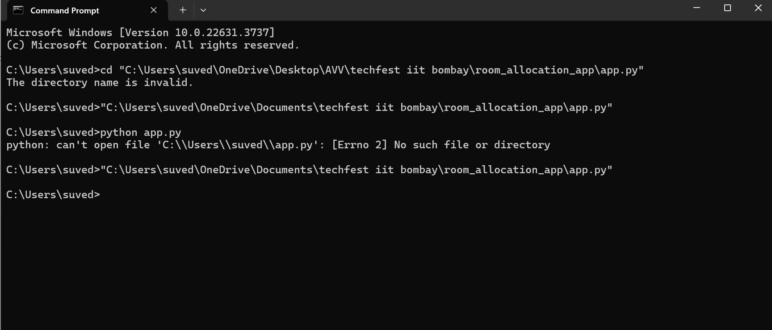

**When u click enter u will see this :**

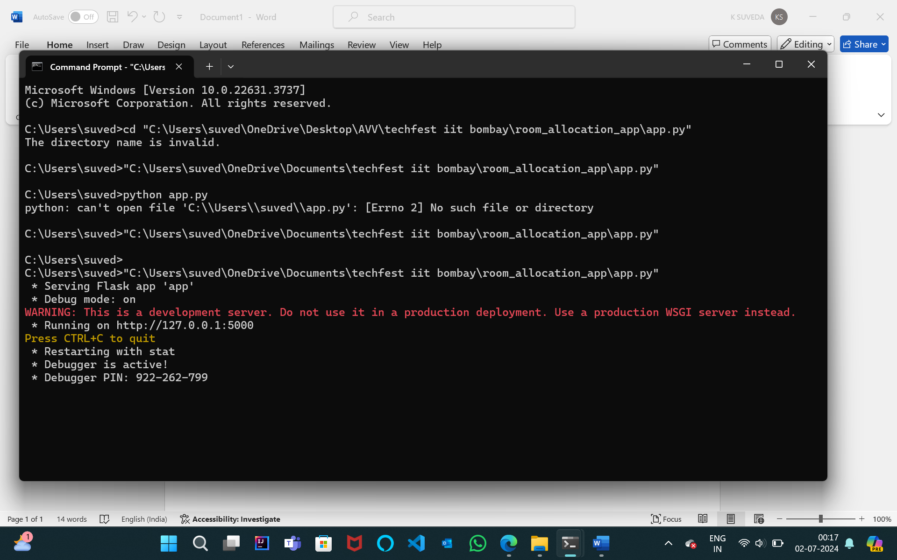

**Then :**

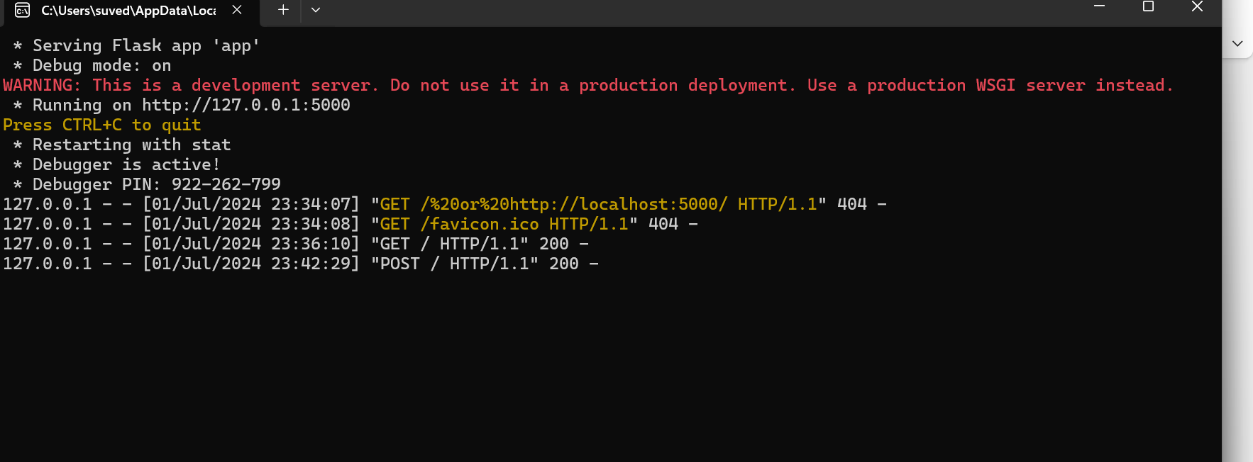

**Go to the browser and click the following link :**

[Room Allocation System](http://127.0.0.1:5000/)  
then the window shows this :

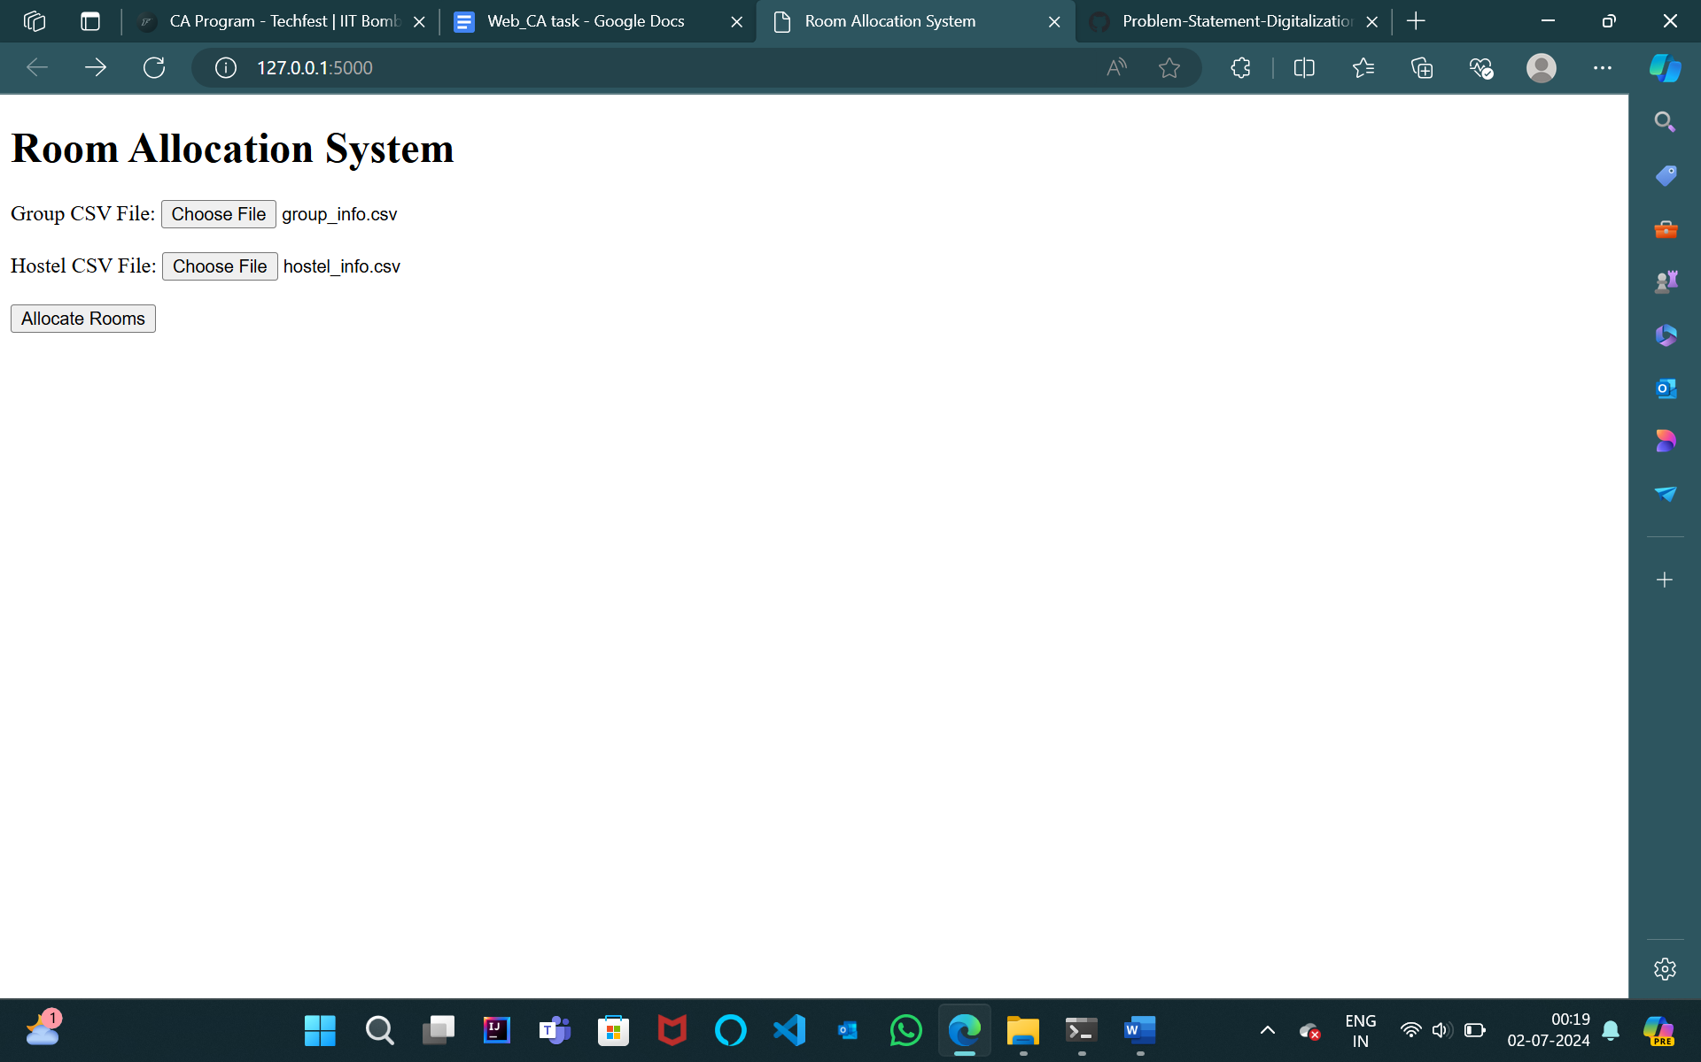

**Then click on allocate rooms :**

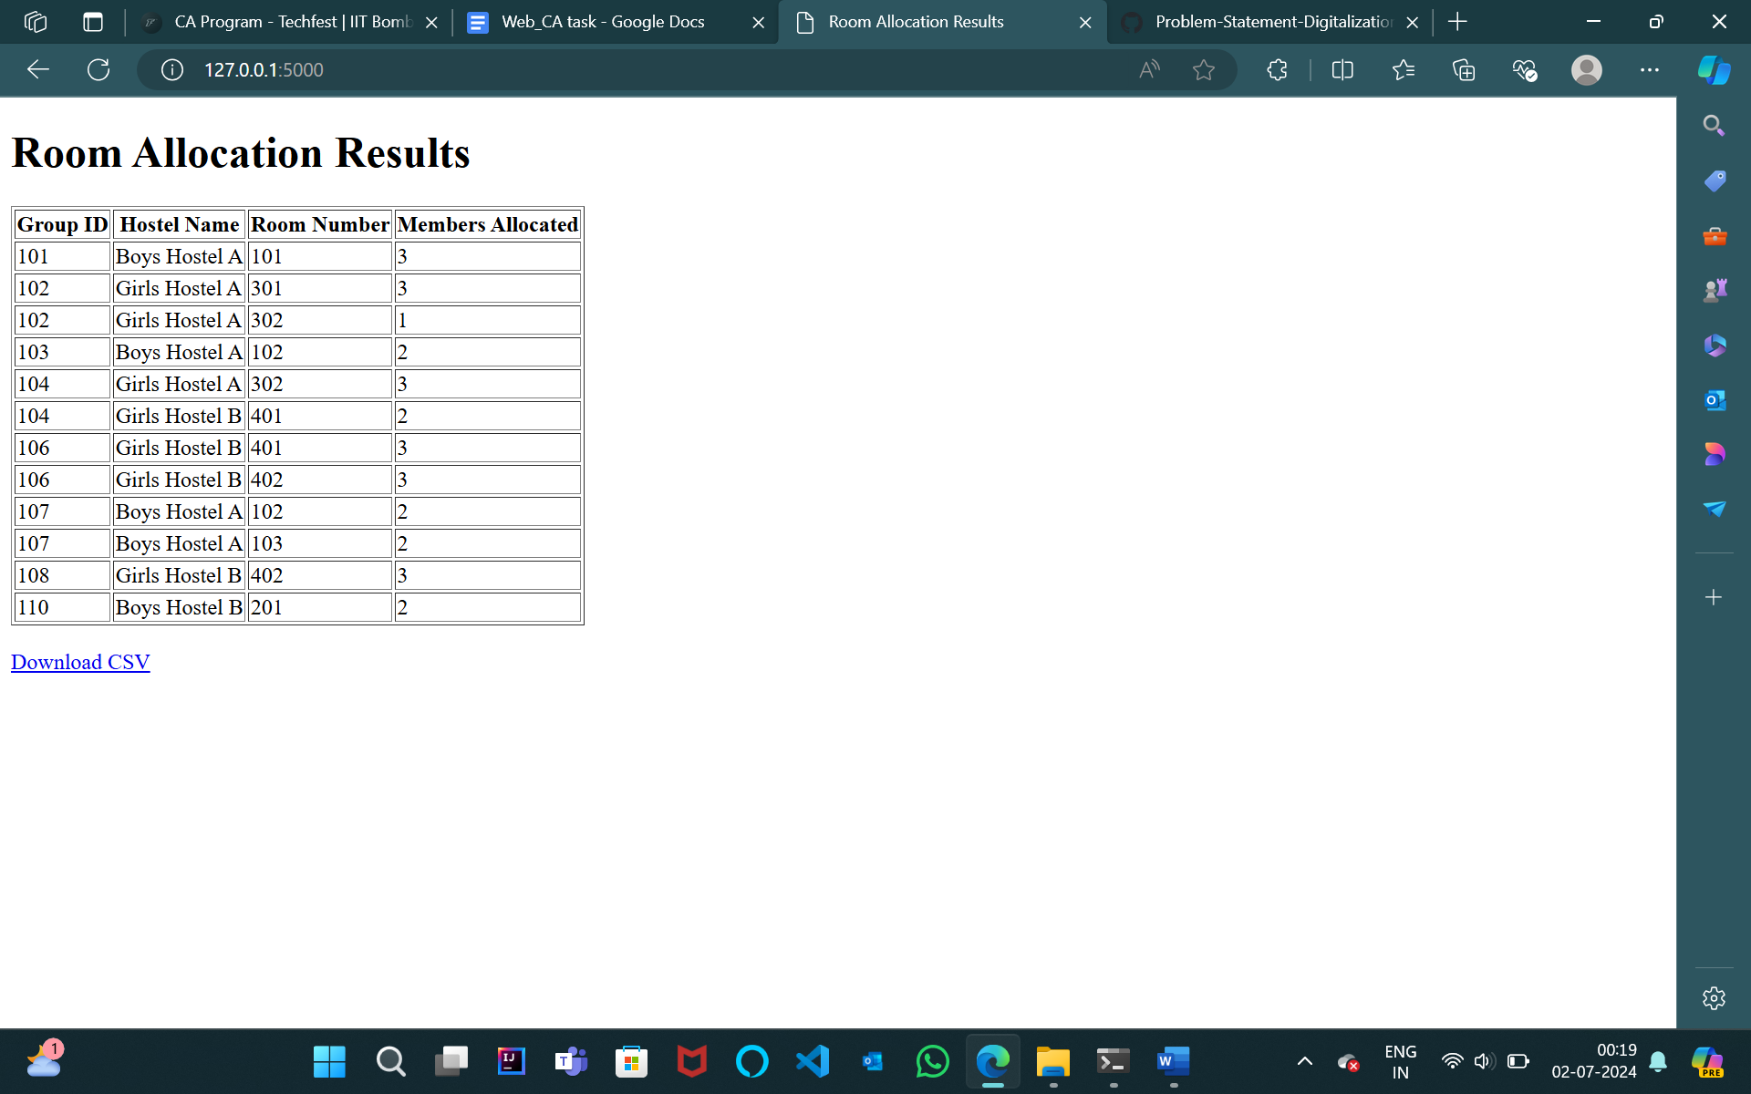

**Click on download csv : u will get an downloaded csv file as per the problem statement**